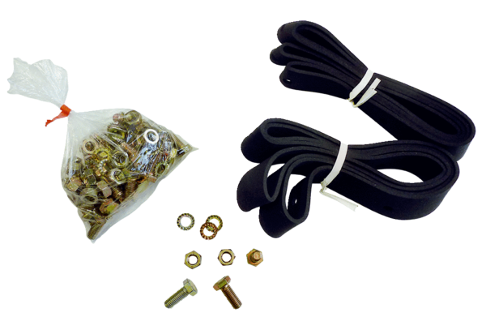Mounting and sealing material BD 50Packing unit: 1 pieceRange: C
Article number: 0092.0138Manufacturer: MAICO

