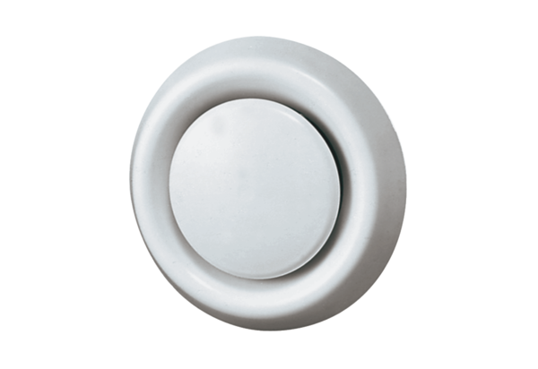Disk valve, synthetic material TK 10Packing unit: 1 pieceRange: C
Article number: 0151.0192Manufacturer: MAICO

