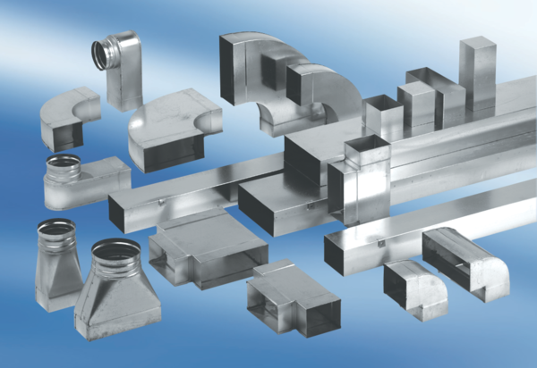Adaptor plug connector SVF70/170Packing unit: 1 pieceRange: K
Article number: 0055.0566Manufacturer: MAICO

