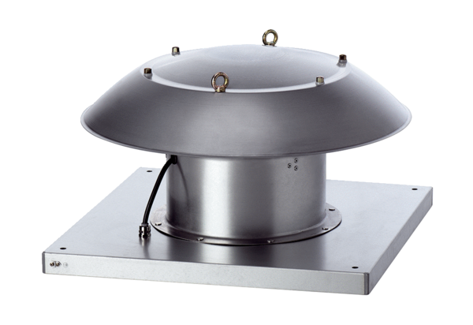Axial roof fan DZD 60/6 B Ex ePacking unit: 1 pieceRange: C
Article number: 0087.0808Manufacturer: MAICO

