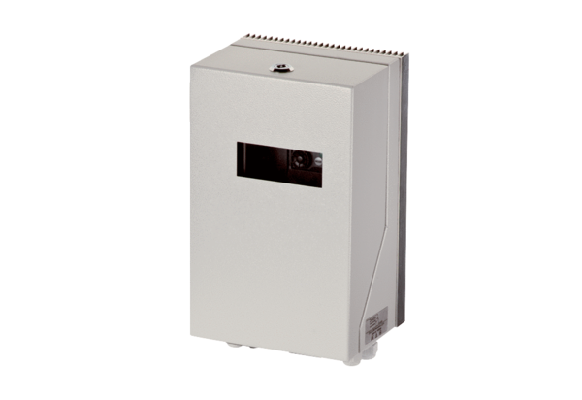Frequency converter MFU 2Packing unit: 1 pieceRange: C
Article number: 0157.1215Manufacturer: MAICO

