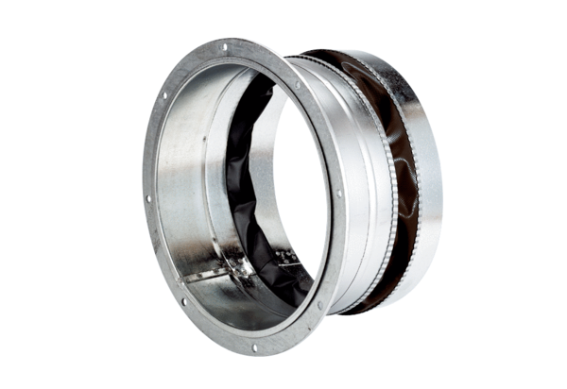Flexible coupling ELA 30 ExPacking unit: 1 pieceRange: C
Article number: 0092.0276Manufacturer: MAICO

