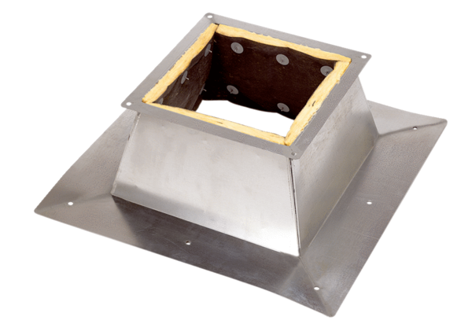Roof socket for flat roofs SO 60Packing unit: 1 pieceRange: C
Article number: 0093.0365Manufacturer: MAICO

