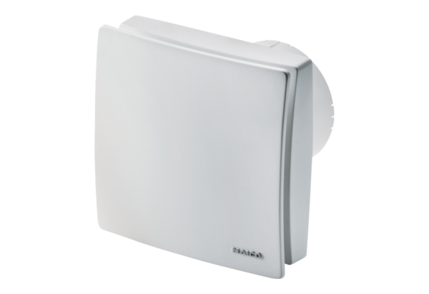Small room fan ECA 100 ipro VZCPacking unit: 1 pieceRange: A
Article number: 0084.0201Manufacturer: MAICO

