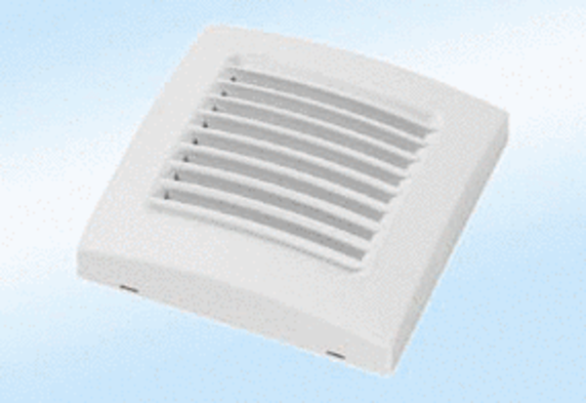Coloured cover A 100 naturaPacking unit: 1 pieceRange: A
Article number: 0092.0364Manufacturer: MAICO

