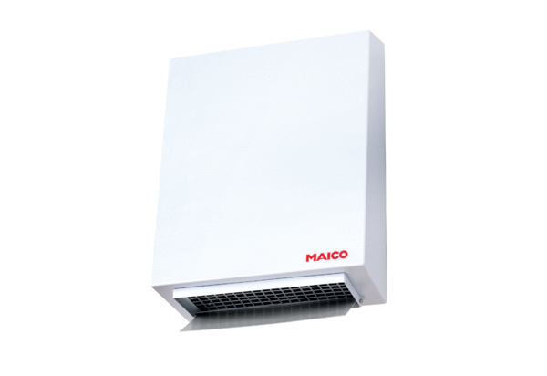Centrifugal external wall fan AWV 20Packing unit: 1 pieceRange: C
Article number: 0080.0998Manufacturer: MAICO

