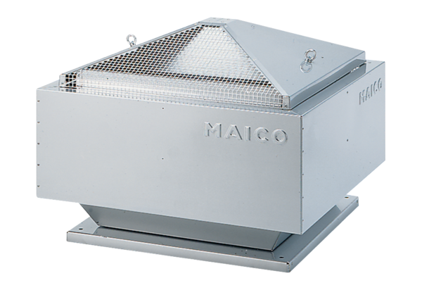Centrifugal roof fan DRD 31/4 BPacking unit: 1 pieceRange: C
Article number: 0087.0104Manufacturer: MAICO

