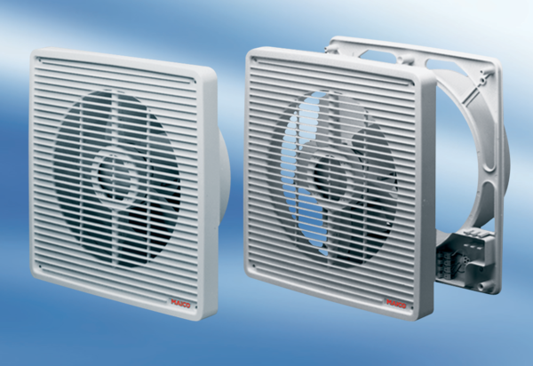Wall-mounted fan ETR 31Packing unit: 1 pieceRange: C
Article number: 0081.0506Manufacturer: MAICO

