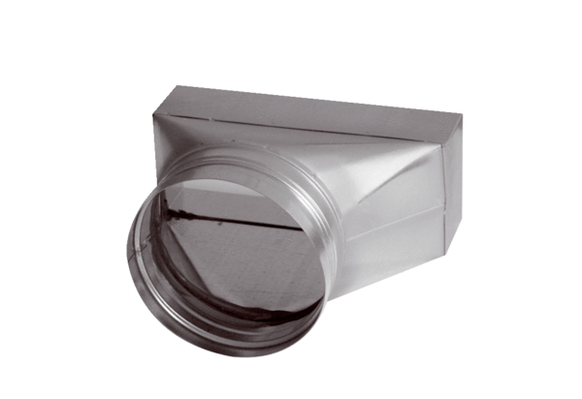Intermediate piece, asymmetric USAN80/150/125Packing unit: 1 pieceRange: K
Article number: 0055.0669Manufacturer: MAICO

