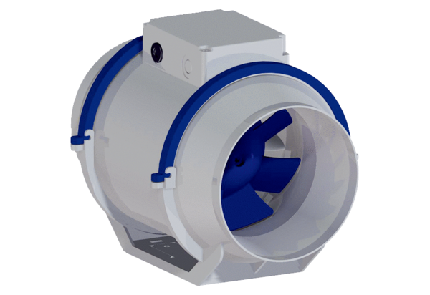Diagonal fan HDR 16Packing unit: 1 pieceRange: C
Article number: 0080.0539Manufacturer: MAICO

