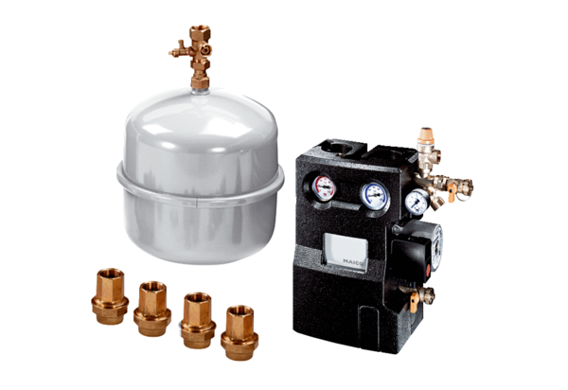Accessories set EW-ZPacking unit: 1 pieceRange: K
Article number: 0092.0488Manufacturer: MAICO

