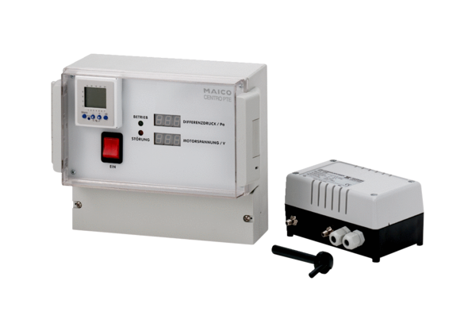Pressure controller Centro-PTEPacking unit: 1 pieceRange: B
Article number: 0157.0400Manufacturer: MAICO

