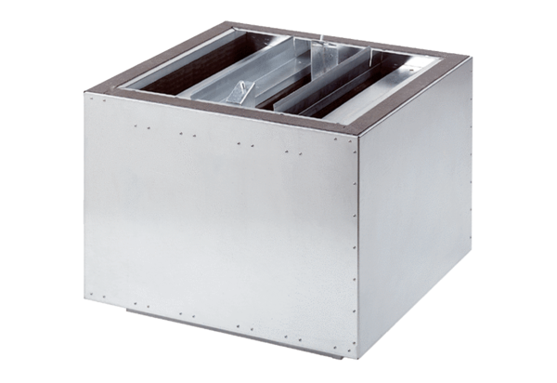Exhaust air silencer SDA 35Packing unit: 1 pieceRange: C
Article number: 0092.0389Manufacturer: MAICO

