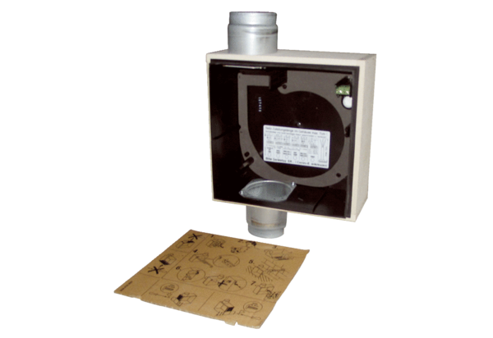Recessed-mounted housing ER - UPB/UPacking unit: 1 pieceRange: B
Article number: 0093.0971Manufacturer: MAICO

