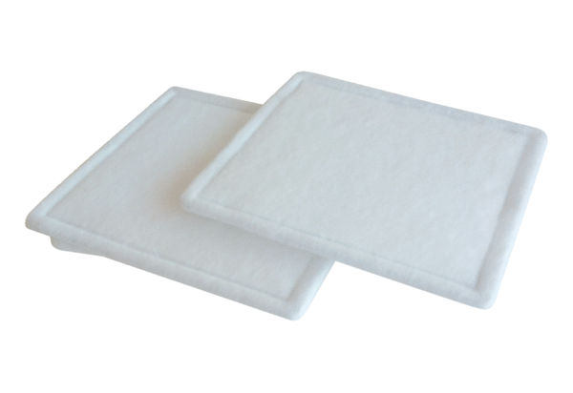Air filter, replacement RF 31-4Packing unit: 2 piecesRange: C
Article number: 0093.0161Manufacturer: MAICO

