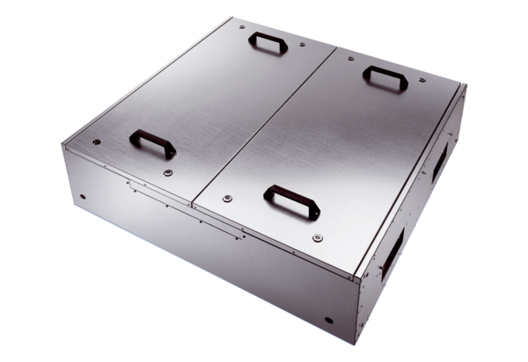Sound-insulated ventilation box KFD 9040-KPacking unit: 1 pieceRange: K
Article number: 0080.0969Manufacturer: MAICO

