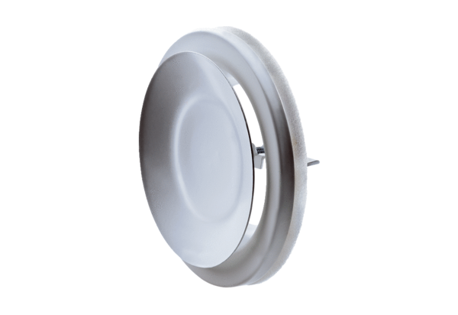Disk valve, metal TFZ 12Packing unit: 1 pieceRange: C
Article number: 0151.0365Manufacturer: MAICO

