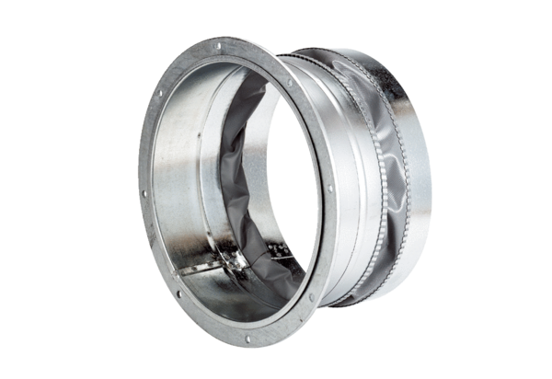Flexible coupling ELA 20Packing unit: 1 pieceRange: C
Article number: 0092.0265Manufacturer: MAICO

