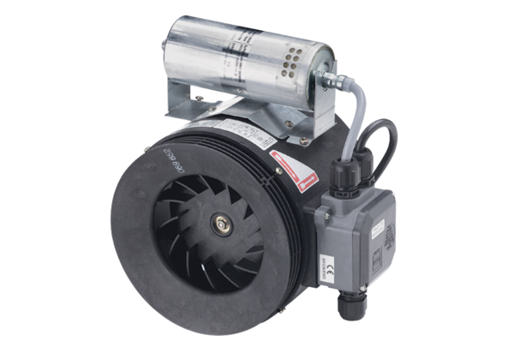Semi-centrifugal duct fan ERM 18 Ex ePacking unit: 1 pieceRange: C
Article number: 0080.0290Manufacturer: MAICO

