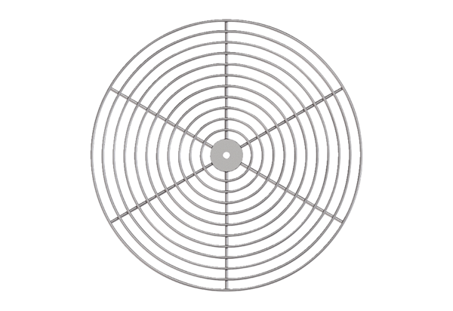Protective grille, metal SG 20Packing unit: 1 pieceRange: C
Article number: 0150.0114Manufacturer: MAICO

