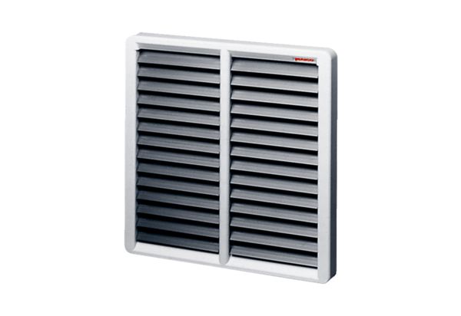Shutter AS 45Packing unit: 1 pieceRange: C
Article number: 0151.0335Manufacturer: MAICO

