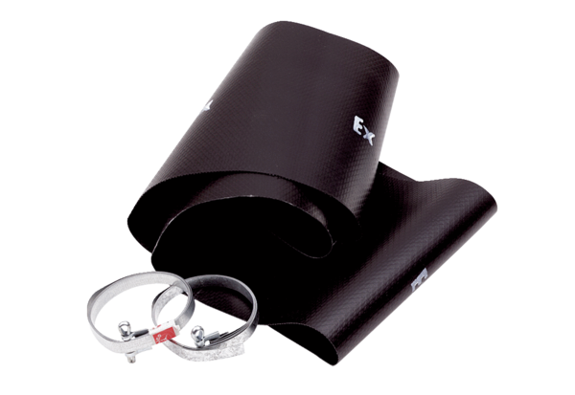Flexible cuff EL 25 ExPacking unit: 1 pieceRange: C
Article number: 0092.0232Manufacturer: MAICO

