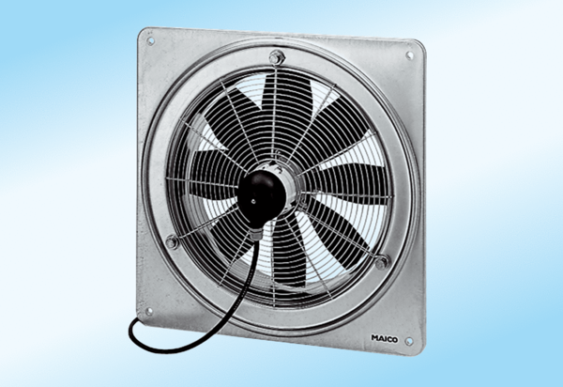Axial wall fan DZQ 30/2 A-ExPacking unit: 1 pieceRange: C
Article number: 0083.0767Manufacturer: MAICO

