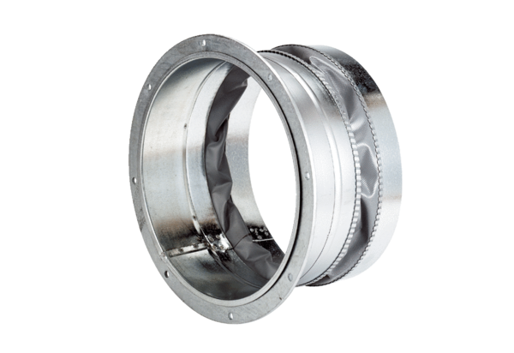Flexible coupling ELA 60Packing unit: 1 pieceRange: C
Article number: 0092.0273Manufacturer: MAICO

