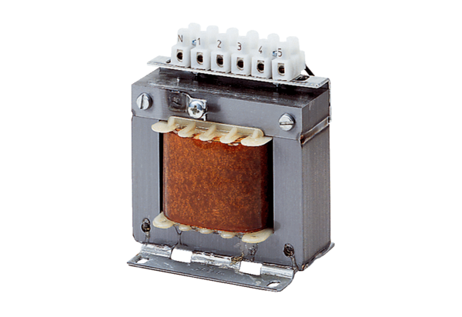5-step transformer, control cabinet TRE 6,5 SPacking unit: 1 pieceRange: C
Article number: 0157.0746Manufacturer: MAICO

