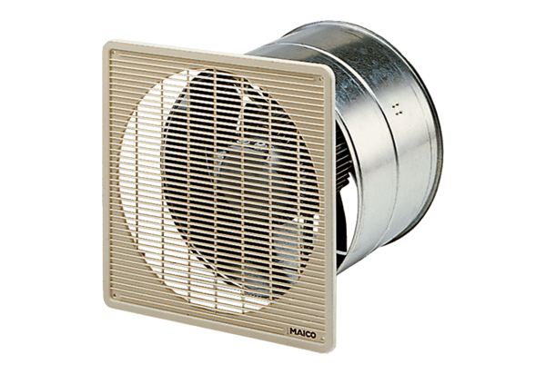DZF 30/6 BPacking unit: 1 pieceRange: C
Article number: 0085.0101Manufacturer: MAICO

