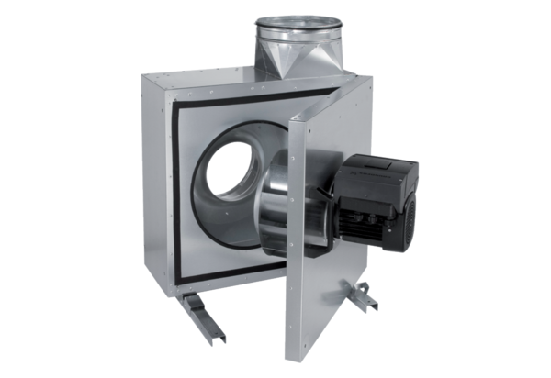Sound-insulated ventilation box EKR 35 FUPacking unit: 1 pieceRange: E
Article number: 0080.0897Manufacturer: MAICO

