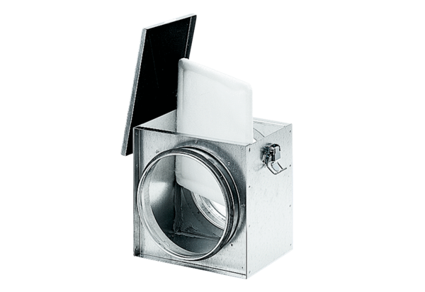Air filter TFE 20-4Packing unit: 1 pieceRange: C
Article number: 0149.0078Manufacturer: MAICO

