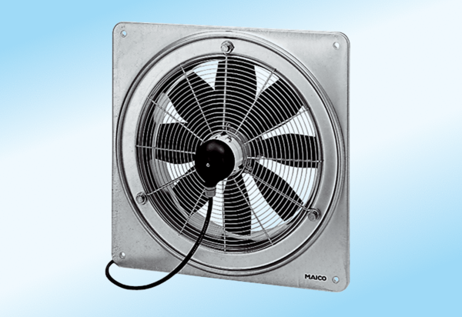Axial wall fan DZQ 20/2 A-ExPacking unit: 1 pieceRange: C
Article number: 0083.0756Manufacturer: MAICO

