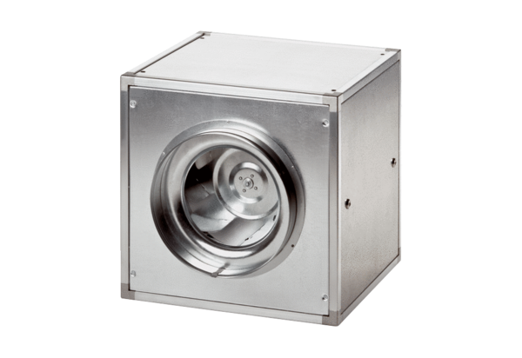Quickbox DSQ 45/4Packing unit: 1 pieceRange: C
Article number: 0080.0036Manufacturer: MAICO

