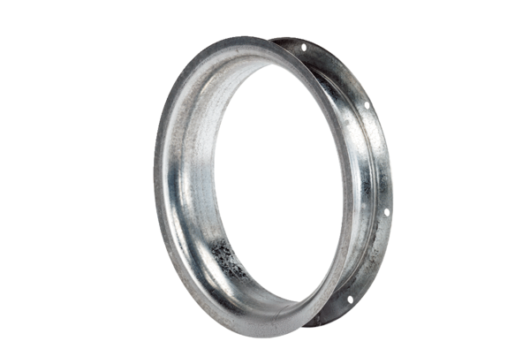Suction nozzle AD 60Packing unit: 1 pieceRange: C
Article number: 0180.0627Manufacturer: MAICO

