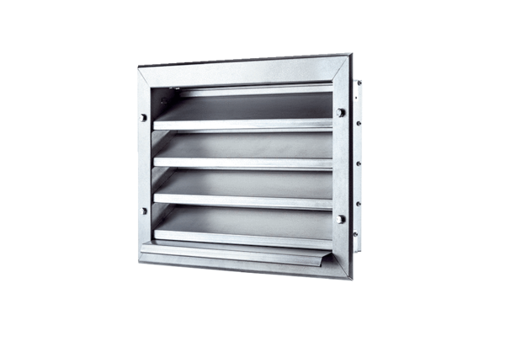External grille LZP 31Packing unit: 1 pieceRange: D
Article number: 0151.0258Manufacturer: MAICO

