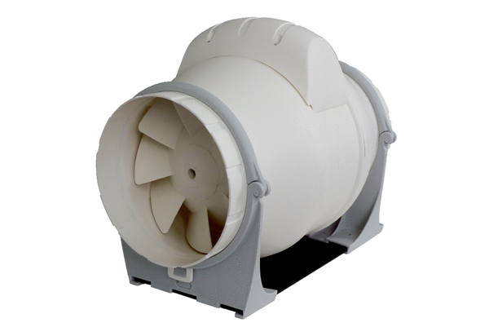Diagonal fan ERK 125 TPacking unit: 1 pieceRange: C
Article number: 0080.0178Manufacturer: MAICO

