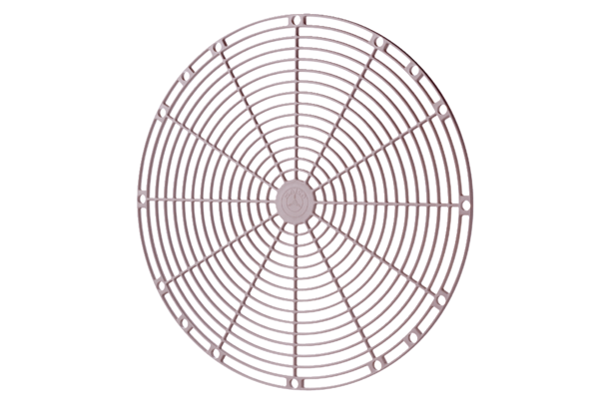Protective grille, synthetic material SGK 35Packing unit: 1 pieceRange: C
Article number: 0059.0164Manufacturer: MAICO

