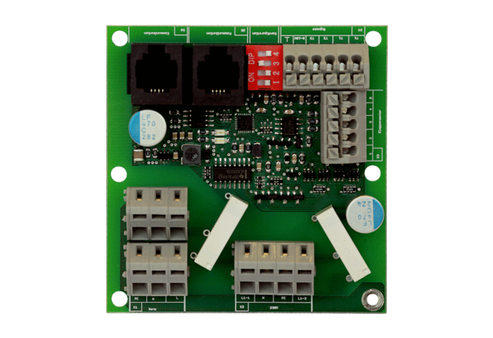Additional circuit board ZP 1Packing unit: 1 pieceRange: K
Article number: 0092.0554Manufacturer: MAICO

