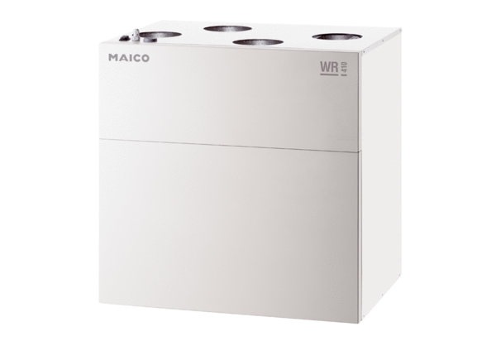Centralised ventilation unit WR 400Packing unit: 1 pieceRange: K
Article number: 0095.0079Manufacturer: MAICO

