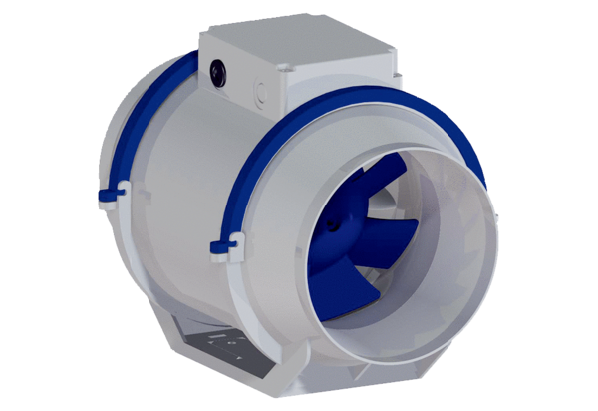Diagonal fan HDR 16 ECPacking unit: 1 pieceRange: E
Article number: 0080.0543Manufacturer: MAICO

