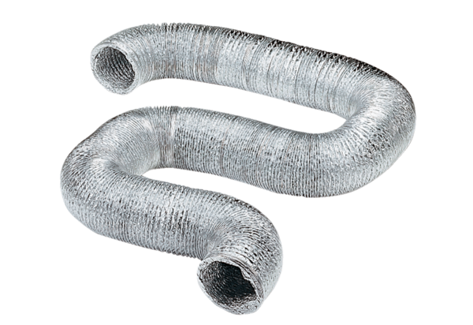Flexible aluminium duct AFR 80Packing unit: 1 pieceRange: B
Article number: 0055.0092Manufacturer: MAICO

