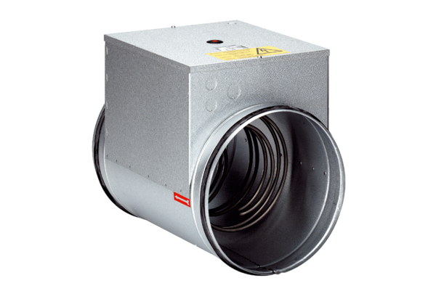Electrical air heater ERH 16-2Packing unit: 1 pieceRange: C
Article number: 0082.0102Manufacturer: MAICO

