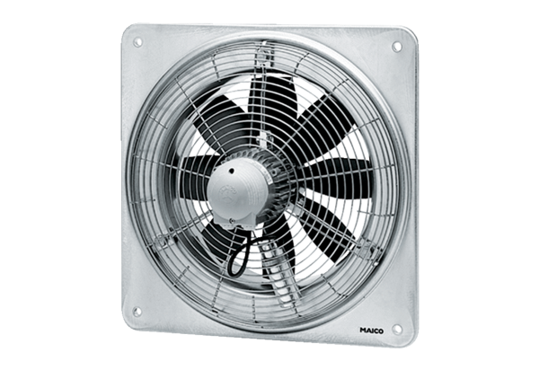Axial wall fan DZQ 45/6 BPacking unit: 1 pieceRange: C
Article number: 0083.0137Manufacturer: MAICO

