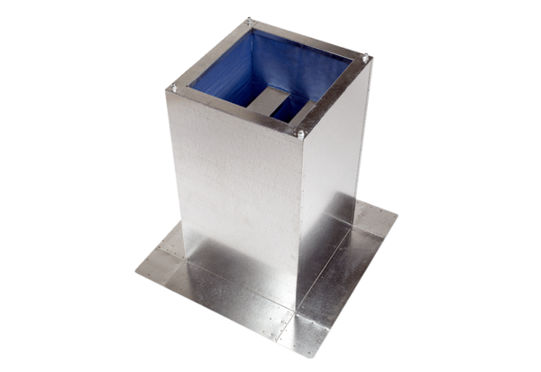Socket sound absorber SD 35Packing unit: 1 pieceRange: C
Article number: 0092.0341Manufacturer: MAICO

