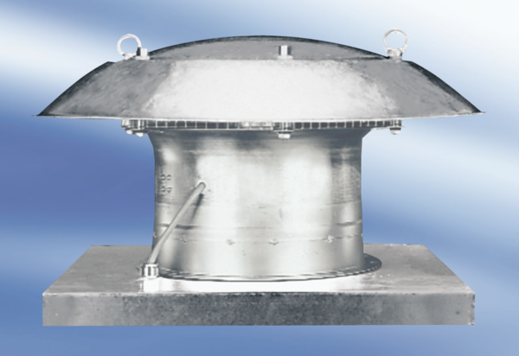Axial roof fan DZD 50/6 A-ExPacking unit: 1 pieceRange: C
Article number: 0087.0785Manufacturer: MAICO

