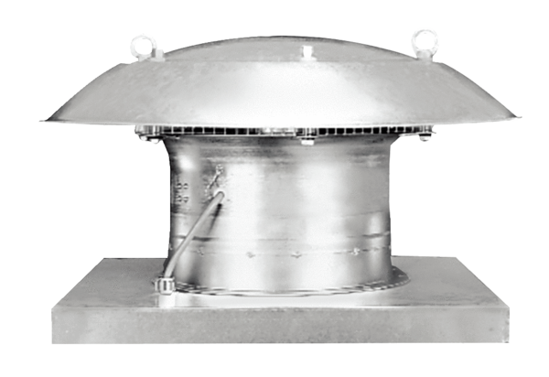Axial roof fan EZD 30/6 BPacking unit: 1 pieceRange: C
Article number: 0087.0203Manufacturer: MAICO

