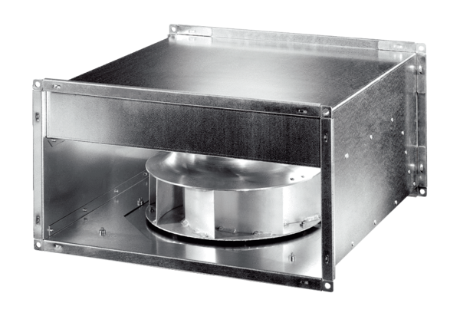Channel fan DPK 35 ECPacking unit: 1 pieceRange: E
Article number: 0086.0806Manufacturer: MAICO

