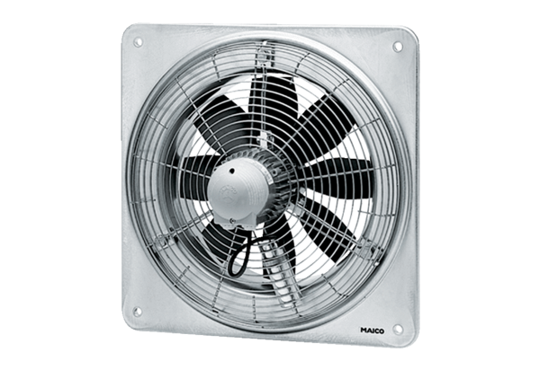Axial wall fan DZQ 60/4 BPacking unit: 1 pieceRange: C
Article number: 0083.0134Manufacturer: MAICO

