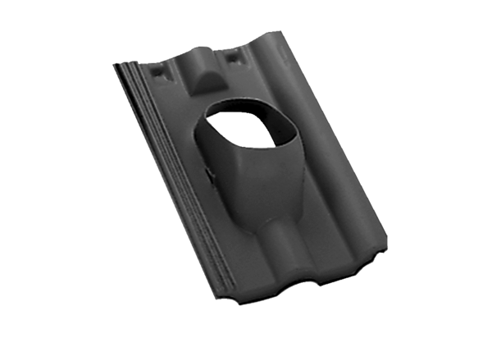Roofing tile DP 125 SFPacking unit: 1 pieceRange: B
Article number: 0092.0377Manufacturer: MAICO

